ACQUA FOUNDATION – PRESS RELEASE

ACQUA FOUNDATION, THE ART CHARITY ORGANIZATION DEDICATED TO SAVING WATER IS LAUNCHING IN VENICE BIENNAL FIRST ARTIST BOX-WATER TO STOP SINGLE USE PLASTIC, WITH A PROJECT DESIGNED BY THE ARTIST ANDRECO, WHO REALIZED THE FIRST WALL-PAINTING ON GRAN CANAL IN VENICE

- ACQUA FOUNDATION is a non profit philanthropy working on Water preservation and Water Global Governance.
- Collaborates with major international and Italian artists to influence public opinion on water
- On the occasion of Venice Biennal ACQUA FOUNDATION is launching the first artist Box-Water designed by Andreco, who realized the first wall-painting on Gran Canal addressing the water rise in Venice
- To celebrate the launch ACQUA FOUNDATION will host an event at Grande Scuola della Misericordia, D/EVOLUTION, a video-art show by Zuecca Project

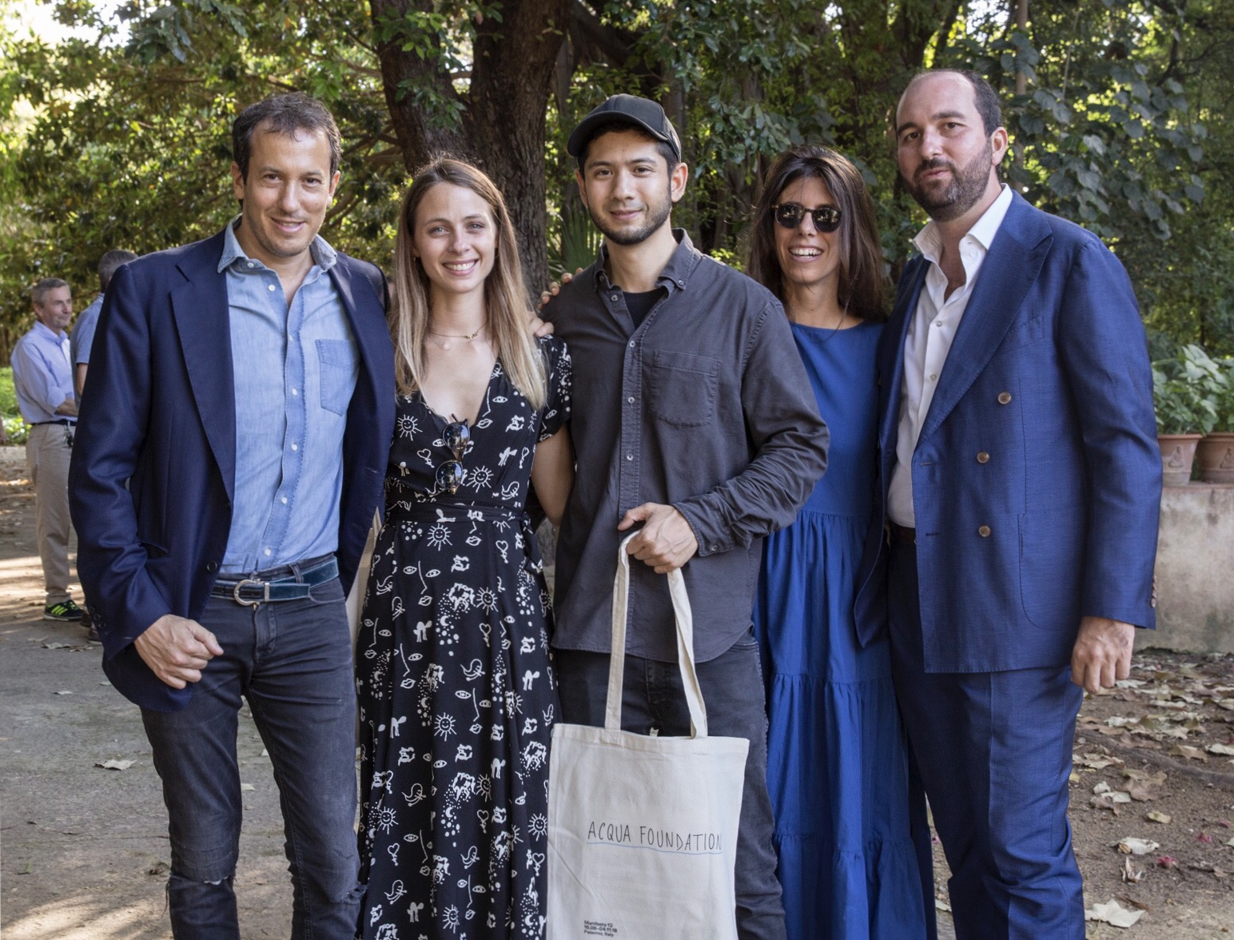

Acqua Foundation co-founders (some members) and Michael Wang at Manifesta 12, Palermo, 2018

ACQUA FOUNDATION funded by 5 young professionals working in various fields from Media, Art, Finance, Fashion and Institutional relations, works to finance strategic international projects on water management and to raise a common institutional awareness for a new, effective, strong Global Water Governance. The aim of ACQUA FOUNDATION is to protect and preserve the most valuable resource that we have: WATER.

ACQUA FOUNDATION biggest challenge is to work to improve water access to all, water sanitization, and ocean preservation on an institutional and technological level and Art is the most powerful tool to spread the organization message and influence public opinion in a strong and effective way.
On the occasion of the Biennale 2019, the association called Andreco, who designed a limited-edition Water-Box. And not only, the artist is present in Venice with Climate#04: the first wall-painting on Gan Canal, on view on Fondamenta Santa Lucia (Central Station), which address climate change and water rise in Venice.

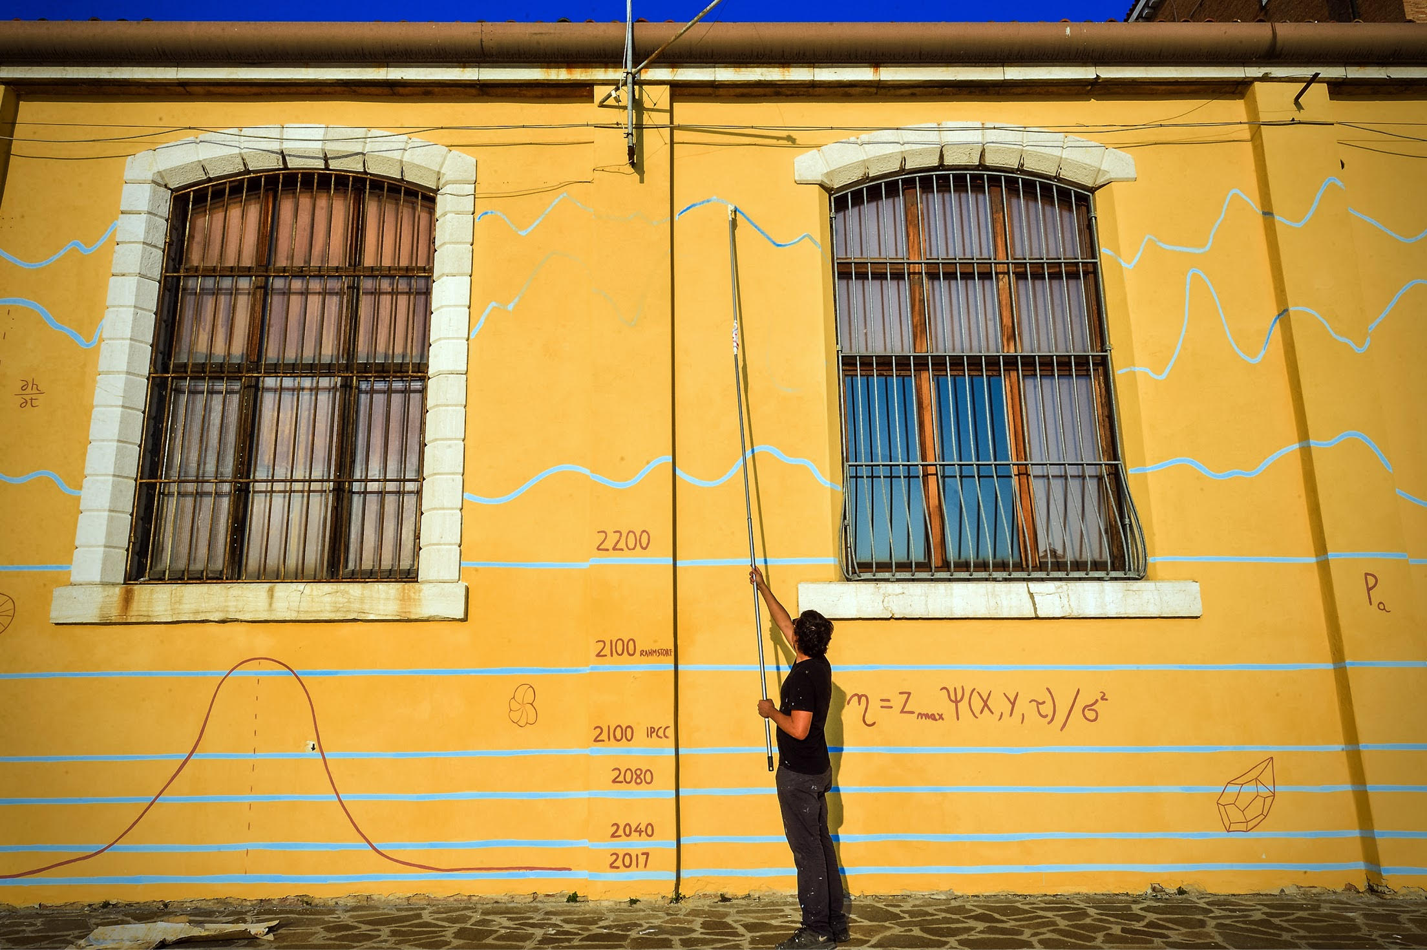

Andreco, Climate#04, Sea Level Rise. Courtesy of the Artist

For Biennal 2019 ACQUA FOUNDATION has organized the launch with an event at the Scuola Grande di Misericordia for the opening of D / EVOLUTION, a video-art exhibition by Zuecca Project that is focus on the theme of the Anthropocene and the way in which humans have changed the ecosystem and the consequent impact on Nature. Five international contemporary artists invited to the exhibition - Adriene Hughes, Ran Slavin, Stefano Cagol, Above&Below + Perry-James Sugden, Sigalit Landau.

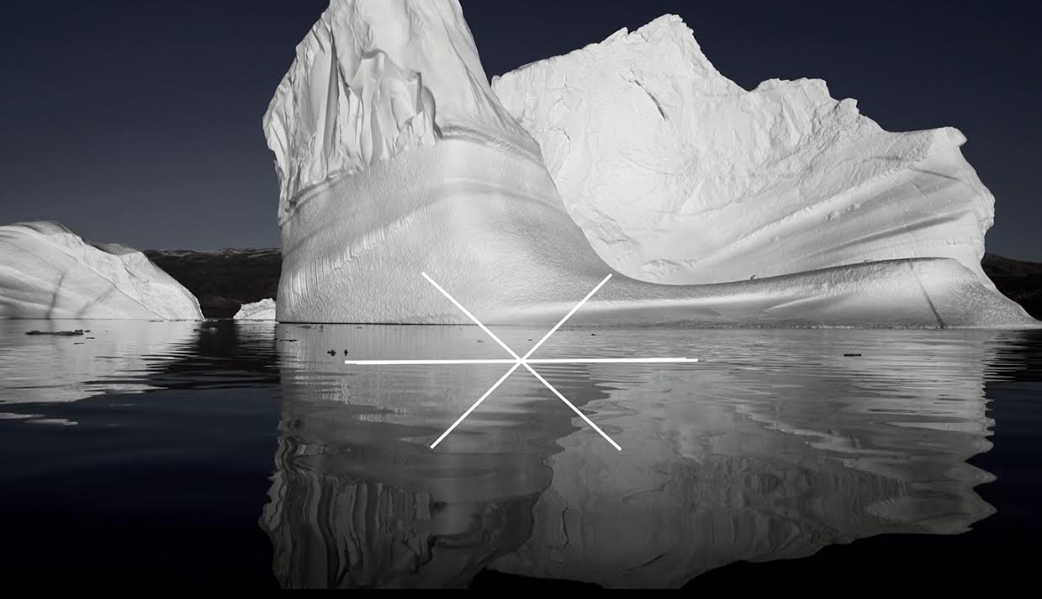

Adriene Hughes, The resonance of loss. D/EVOLUTION, Venice, 2019

INFO
Scuola Grande di Santa Maria della Misericordia - 10 maggio 2019 -18h

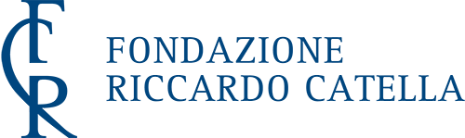

www.acquafoundation.com

